Habeba Ahmed

Habebaahmed101@gmail.com

Abstract

A project that covers Python topics under the Embedded Linux Diploma by Eng. Mohamed Bakr

Python project

Employee Management System

Table Content

1. Problem Statement
2. Approach
3. Idea
4. Main.py
5. Employee_data.py

* Add an employee record
* Remove an employee record
* Update an employee record
* Checking duplicate IDs

1. Operations.py

* Display user Information
* Calculate Employee Bonus
* Calculate Employee Discount
* Legal Holiday Reminder
* Exit Function

1. Authentication.py

* Login

Problem Statement

It is software for the Employee Management System which can perform the following operations.

* Login using Employee ID and password stored in the System.
* Add Employee Record.
* Remove Employee record.
* Update Employee records.
* Checking duplicate IDs.
* Display user Information.
* Calculate Employee Bonus.
* Calculate Employee Discount.
* Legal Holiday Reminder.
* Exit Function.

Approach

The idea is to form individual functions for every operations, the data structures used is a list of dictionaries, each dictionary is an Employee record with all its information stored in a key-value manner.

Idea

It consists of 4 python files main.py, employee_data.py, operations.py, authentication.py.

The main contains function Calling.

The employee_data.py contains the data manipulation functions.

The operations.py contains the functions that use Employee Data.

The authentication.py contains the function used to authenticate user logging in.

Main.py

The main contains the calling of the functions created in the modules imported which are authentication.py, employee_data.py, and operations.py. The functions are called based on the user input from 1 to 8.

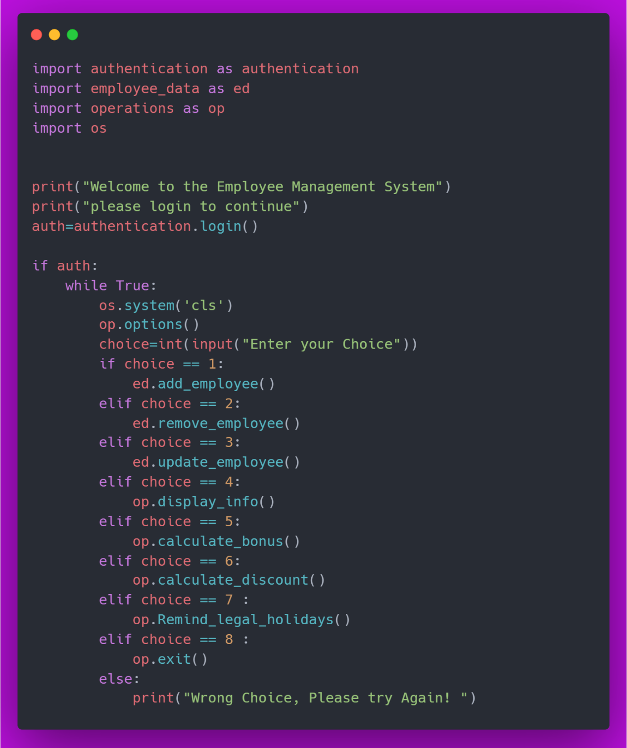

Employee_data.py

1. Add_employee

The function has the implementation steps to take the data from the user and store it in the list.

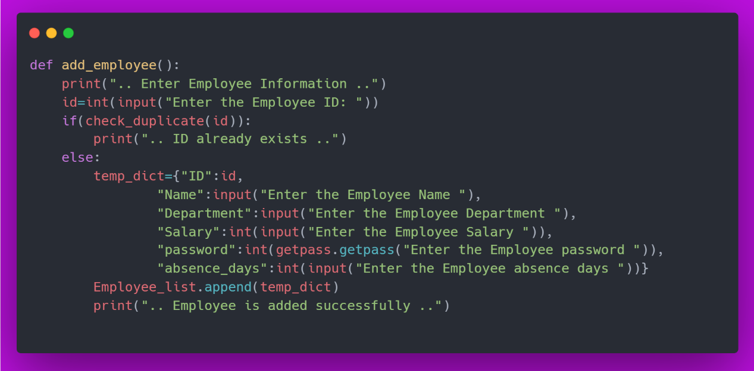

1. Remove_employee

The function has the implementation steps to remove an employee record from the system based on an ID taken from the user.

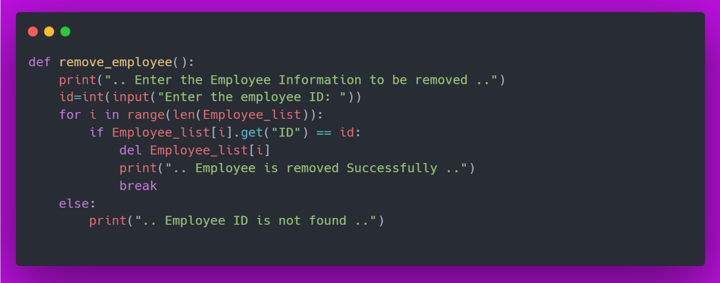

1. Update_employee

The function has the implementation steps to update an employee record

In the system, based on an ID taken from the user.

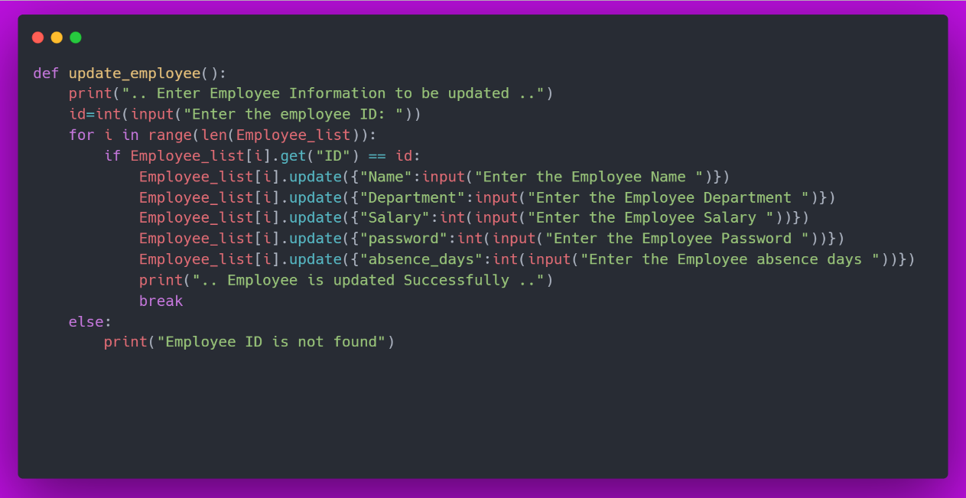

1. Check_duplicates

The function has the implementation steps to take an ID and check if it exists in the system or not so the IDs are unique in the system.

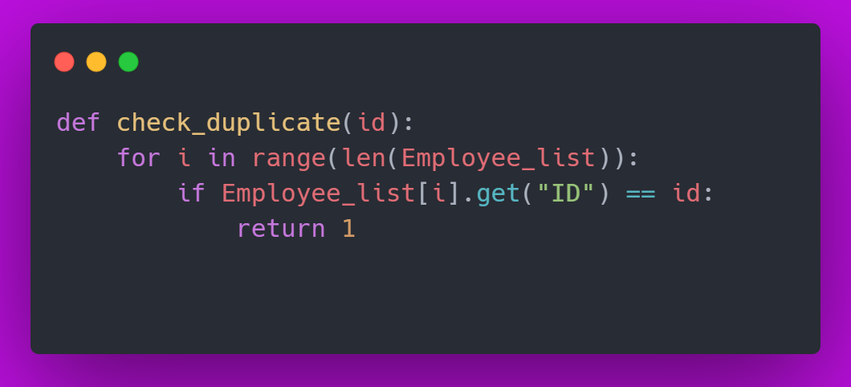

Operations.py

1. Display_info

The function has the implementation steps to show an employee record based on the ID given by the user.

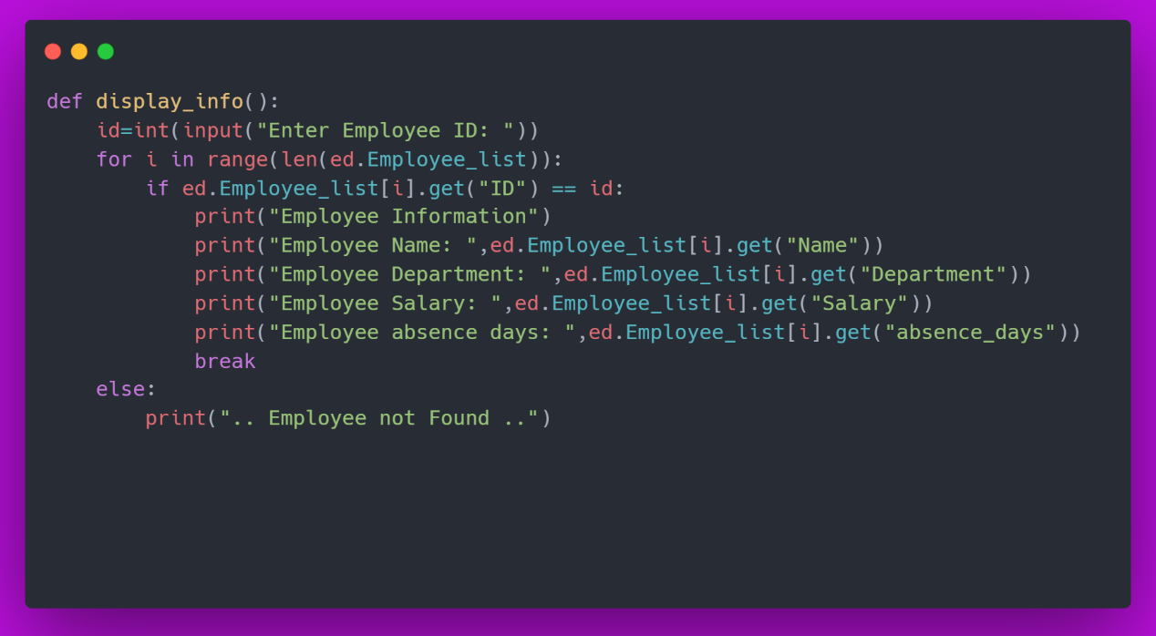

1. Calculate_bonus

The function has the implementation steps to calculate bonus as a percentage of Employee Salary.

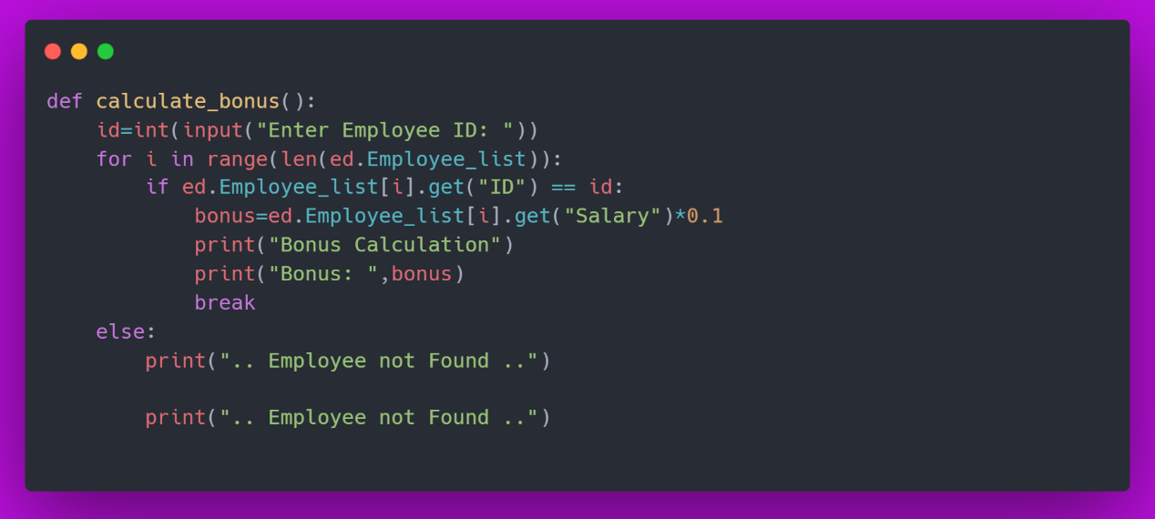

1. Calculate_discount

The function has the implementation steps to calculate discount as a percentage of Employee Salary.

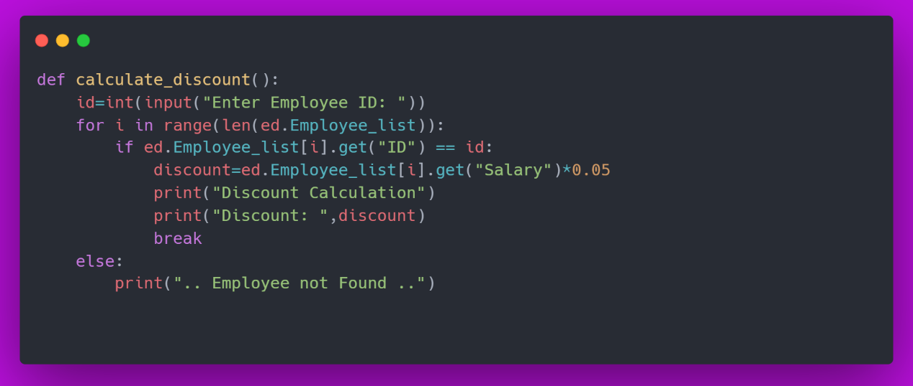

1. Remind_legal_holidays

The function has the implementation steps to show Employee Holidays left according to the absences days They took.

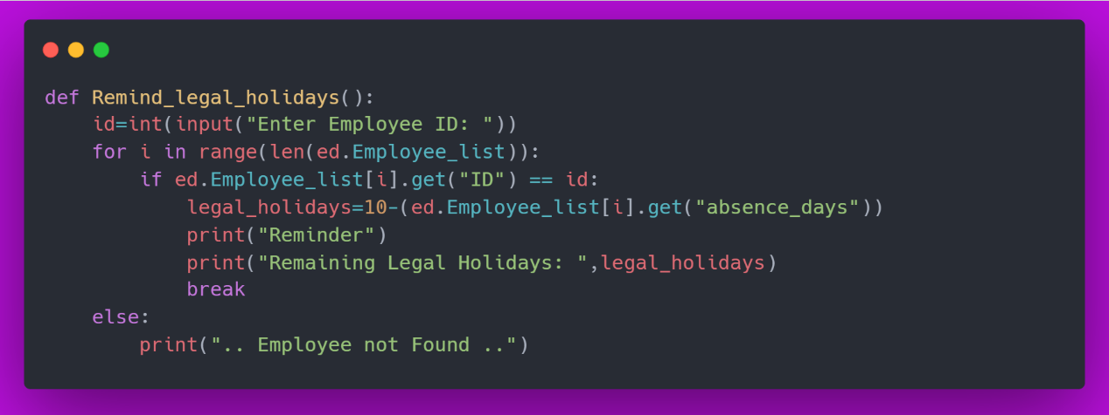

1. Exit

The function has the implementation steps to terminate the program.

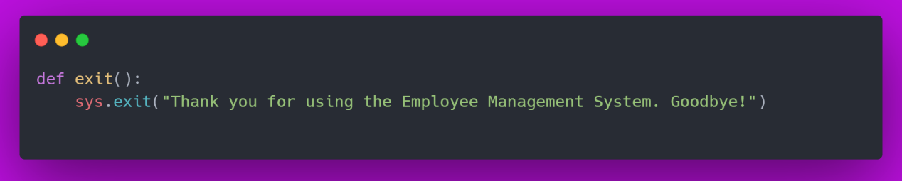

1. Options

The function has the implementation steps to show the options available to the user to choose from.

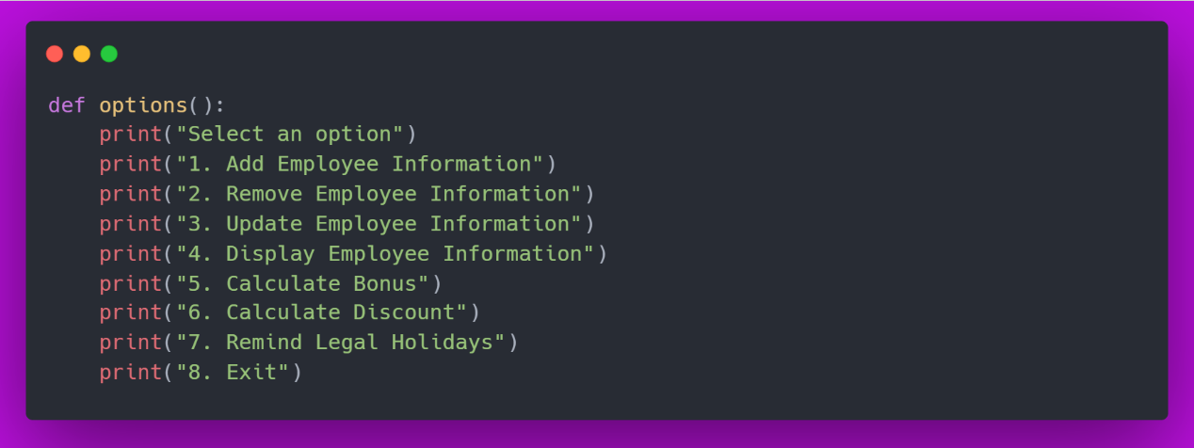

Authentication.py

Login

The function has the implementation steps to verify the user login to the system using his ID and password.

